­­­

© TIA 2017 TIA Tool and Engineers Institute, Inc.

No part of this publication may be reproduced in any form, in an electronic retrieval system or otherwise, without the prior written permission of the publisher.

Setup GUIDE

REVOV Batteries

­­­

REVOV R100 to Inverter interfacing Guide

REVOV R100 to inverter interfacing wiring by inverter brand.



**CONTENTS**

1. Introduction 1

2. Communication interface and transmission rate 1

2.1 RJ45 pinout 1

3. Communication hierarchy 1

4. BMS Addressing and Master/Slave setting 2

5. Compatible inverter setup 2

5.1 Lux Power Setup 2

5.1.1 Wiring 2

5.1.2 Inverter Setup 3

5.2 MGRN Setup 3

5.2.1 Wiring 3

5.2.2 Inverter Setup 3

5.3 Deye Setup 3

5.3.1 Wiring 3

5.3.2 Inverter Setup 4

5.4 Sunsynk Setup 5

5.4.1 Wiring 5

5.4.2 Inverter Setup 5

5.5 Growatt Setup 6

5.5.1 Wiring 6

5.5.2 Inverter Setup 6

5.6 Victron 6

5.6.1 Wiring 6

5.6.2 Inverter Setup 7

5.7 Studer Setup 7

5.7.1 Wiring 7

5.7.2 Inverter Setup 7

# Introduction

This document outlines the connections and settings from the R100 from REVOV to various inverter brands.

# Communication interface and transmission rate

BMS data communication uses asynchronous differential serial communication. Asynchronous serial communication interface and transfer rate is set as below for the following protocols:

CAN-bus 2.0 A:

* Baud rate of 500kbits/s
* 11-bit Addressing.

Inter-BMS RS485:

* Connect a straight through cable between the right most RS485 ports of the Master and Slave BMS ports. Should more than one slave BMS be used, please use the RS485 inter-BMS ports to connect from the first slave to the next slave and so on.

## RJ45 pinout

The pins for the high and low busses of the CAN 2.0A communication is as follows on the RJ45 communication ports marked CAN on the master BMS:

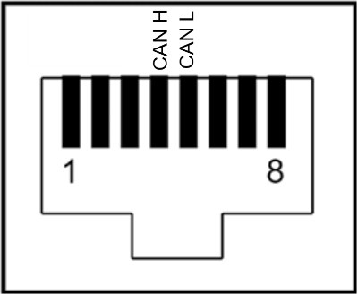

Figure 1: Front view of a female RJ45 port on the BMS with CAN pinout.

The pins for the CAN bus of the BMS is pin 4 (CAN High) and pin 5 (CAN Low) as shown in figure 1 of a female RJ45 Port. The CAN port is the RJ45 port to the very right of figure 2.

# Communication hierarchy

The BMS communicates using RS485, which is a differential protocol. The master BMS (address 1) queries the other BMS addresses, consolidates the information and send the consolidated information to the inverter using CAN. The monitoring system is a distributed structure, the communication between the master R100 and slave R100s.

# BMS Addressing and Master/Slave setting

The BMS address is set using 4 dip switches representing 4 bits. A total of 15 BMS can be paralleled as 15 addresses are available. The switches can be found above the LED indicators on the BMS. The BMS is oriented as shown in figure 2 for the image and explanation in figure 3.

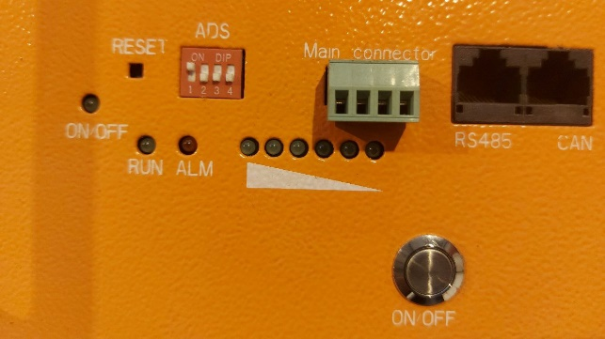

Figure 2: Image of BMS orientation (master BMS DIP setting).

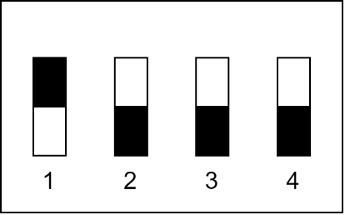

Figure 3: Dip switches on the BMS. In the image the bits are set for the master BMS.

The dip switches in figure 3 are used for the BMS addressing as follows:

**Example:** Dip configuration from left to right: 1000: ADR = 1 (Master R100)

0100: ADR = 2 (Slave R100)

0111: ADR = 14 (Slave R100)

# Compatible inverter setup

## Lux Power Setup

### Wiring

|  |  |  |
| --- | --- | --- |
| **Comm Pins** | **BMS Pins** | **Inverter Pins** |
| CAN H | 4 | 4 |
| CAN L | 5 | 3 |

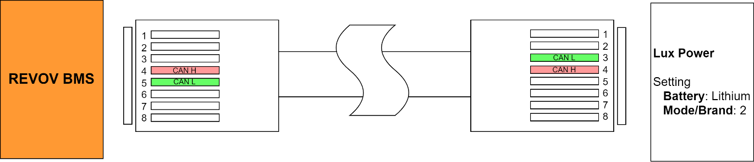

Figure 4: Lux Power RJ45 cable wiring.

### Inverter Setup

1. Connect to the CAN port of the inverter.
2. Hold **Enter** to enter the settings on the inverter.
3. Select option 3 (battery chemistry).
4. Select **Lithium**.
5. Select brand and mode **2**.
6. Press **Enter**.
7. And **Return**.

## MGRN Setup

### Wiring

|  |  |  |
| --- | --- | --- |
| **Comm Pins** | **BMS Pins** | **Inverter Pins** |
| CAN H | 4 | 4 |
| CAN L | 5 | 5 |

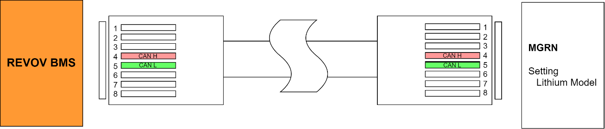

Figure 5: MGRN RJ45 cable wiring.

### Inverter Setup

1. Connect to the CAN port of the inverter.
2. Select **LITHIUM** model.

## Deye Setup

### Wiring

|  |  |  |
| --- | --- | --- |
| **Comm Pins** | **BMS Pins** | **Inverter Pins** |
| CAN H | 4 | 4 |
| CAN L | 5 | 5 |

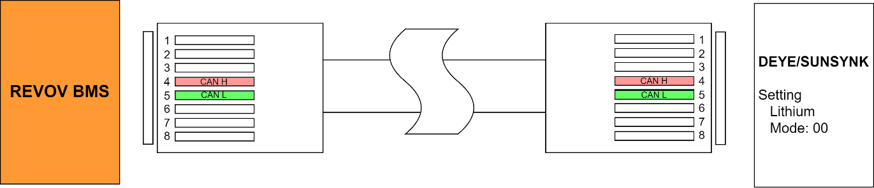

Figure 6: Deye RJ45 cable wiring.

### Inverter Setup

Let **N** resemble the total number of R100s connected to the Inverter.

The **select** refers to a tick in the bottom right corner of the current screen.

**Page down** refers to the down arrow near the right edge of the current display.

1. Connect to the CAN port of the inverter.
2. Press the **gear icon** in the top right of the home display.
3. Press **battery settings.**
4. Select Use **Batt V**
   1. Battery capacity: (N*100Ah)
   2. Max charge: (N*80A)
   3. Max discharge: (N*80A)
   4. Press **select**
5. Press **battery settings**
6. Press **page down**
   1. Select **Grid charge**
   2. Select **Grid signal**
   3. Set voltage to **49V**
   4. Max charge current from Grid: **60A**
   5. Press **select**
7. Press **battery settings**
8. Press **page down**
9. Press **page down**
   1. Float voltage: **54.5V**
   2. Absorption voltage: **55.5V**
   3. Equalisation voltage: **57V**
   4. Equalisation Days: **0 days**
   5. Equalisation Hours: **0 Hrs**
   6. Low Batt voltage **49.0V**
   7. Shutdown voltage **48V**
   8. Restart voltage **49.5V**
   9. Tempco: **0**
   10. Batt Resistance: **1mOhm**
   11. Press **select**
10. Press **Battery settings**
11. Select **Lithium** configuration
    1. **Battery capacity** - check
    2. **Max charge** - check
    3. **Max discharge** - check
    4. Press **select**
12. Press **Battery settings**
13. Press **page down**
    1. Battery charge percentage: **10%**
    2. Max charge current from Grid: **60A**
    3. Select **Grid Charge**
    4. Select **Grid Signal**
    5. Press **select**
14. Press **battery settings**
15. Press **page down**
16. Press **page down**
    1. Lithium mode: **00**
    2. Shutdown percentage: **5%**
    3. Low Batt percentage: **10%**
    4. Restart percentage: **15%**
    5. Press **select**

## Sunsynk Setup

### Wiring

|  |  |  |
| --- | --- | --- |
| **Comm Pins** | **BMS Pins** | **Inverter Pins** |
| CAN H | 4 | 4 |
| CAN L | 5 | 5 |



Figure 7: Sunsynk RJ45 cable wiring.

### Inverter Setup

Let **N** resemble the total number of R100s connected to the Inverter.

1. Connect to the CAN port of the inverter.
2. Press the **gear icon** in the top right of the home display.
3. Enter the **battery settings**.
4. Select **AGM V** as battery chemistry:
   1. Battery capacity: (N*100Ah)
   2. Max charge: (N*80A)
   3. Max discharge: (N*80A)
   4. Press **OK**.
5. Enter the **Battery Settings** again.
6. Select **Batt Charge** (middle tab near the top of the display)
   1. Check **Grid charge.**
   2. Check **Grid signal**.
   3. Float V: **54.5V**
   4. Absorption V: **55.5V**
   5. Equalization V: **57V**
   6. Equalization Days: **0 Days**
   7. Equalization Hours: **0 Hours**
   8. Press **OK**.
7. Enter the **Battery Settings**.
8. Select **Shut Down** (last tab)
   1. Shut Down: **48V**
   2. Low Batt: **49V**
   3. Restart: **49.5V**
   4. Press **OK**.
9. Enter the **Battery Settings**.
   1. Select **LITHIUM**.
   2. Select **CAN**.
   3. Protocol: **0**
   4. Press **OK**.
10. Enter the **Battery Settings**.
11. Select the **Shut Down** tab again.
    1. Shut Down: **5%**
    2. Low Batt: **10%**
    3. Restart: **15%**
    4. Press **OK**.

## Growatt Setup

### Wiring

|  |  |  |
| --- | --- | --- |
| **Comm Pins** | **BMS Pins** | **Inverter Pins** |
| CAN H | 4 | 4 |
| CAN L | 5 | 5 |

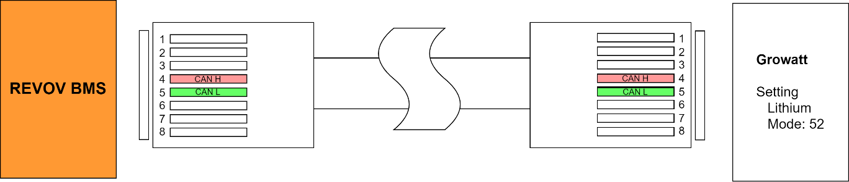

Figure 8: Growatt RJ45 cable wiring.

### Inverter Setup

1. Connect to the CAN port of the inverter.
2. Select **LITHIUM** battery chemistry.
3. Select Lithium Mode 52.

## Victron

### Wiring

|  |  |  |
| --- | --- | --- |
| **Comm Pins** | **BMS Pins** | **Inverter Pins** |
| CAN H | 4 | 7 |
| CAN L | 5 | 8 |

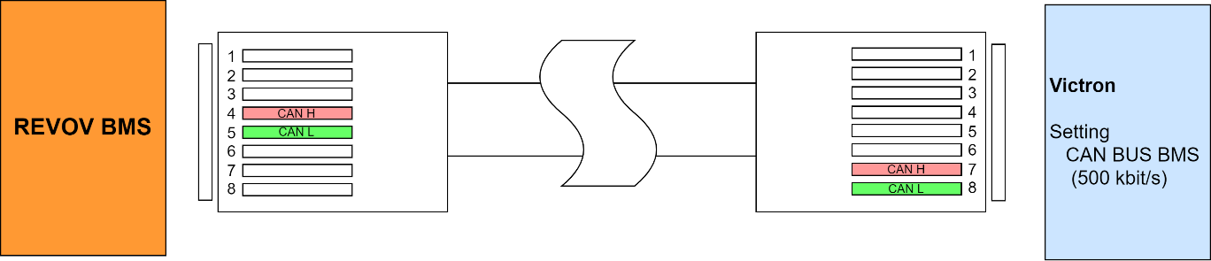

Figure 9: Victron RJ45 cable wiring.

### Inverter Setup

1. Connect to the CAN port of the inverter.
2. Select **CAN-bus BMS (500kbits/s)** CAN-profile in the GX device. Menu path: Settings -> Services -> VE.CAN port.
3. After proper setup and wiring, the battery will be visible in the device list.

## Studer Setup

### Wiring

|  |  |  |
| --- | --- | --- |
| **Comm Pins** | **BMS Pins** | **Inverter Pins** |
| CAN H | 4 | 4 |
| CAN L | 5 | 5 |

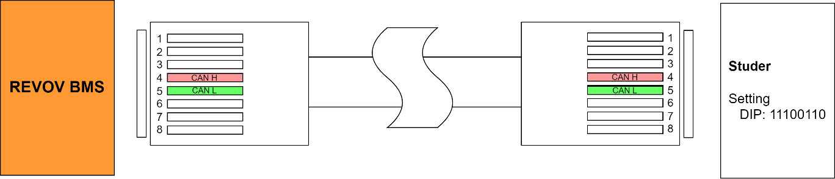

Figure 10: Studer RJ45 cable wiring.

### Inverter Setup

1. Connect to the CAN port of the inverter.
2. Set the DIP configuration as: 11100110.
3. CAN bus speed to 500 kb/s.
4. Set Jumper array by 4-CAN-H and 5-CAN-L