Kodak BL Battery compatibility Application

**This is an internal document and should not be shared with customers.**

The Kodak BL3.6 and BL5.0 are compatible to parallel.

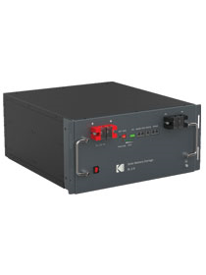

**This is not an advised configuration but if a customer must pair these models, please note the following:**

* The customer must understand and be made aware that this configuration may affect their warranty terms if connected differently from the advised configuration.
* The customer must acknowledge and be made aware that the battery bank will operate as a BL3.6 battery bank.

**Advise the customer to always make the BL3.6 the Master unit in this configuration:**

1. Set BL3.6 as Master unit when setting up.
2. Dip switch settings are as per user manual, refer to page 7, paragraph 2.3.1.
3. BMS Communication is as per manual page 8.
4. Installation and configuration are the same as when you parallel the same capacity size battery.
5. Fault codes and warning are as of the same battery type connection, please refer to manual for detailed information.

Due to the BL5.0 having different parameters than that of the BL3.6, to protect the BL3.6 in such a case it is advised to the BL3.6 as the Master battery.